**A**

**Mini Project Report**

**On**

**AN INTELLIGENT TRAFFIC MANAGEMENT SYSTEM**

**SIDDHARTHA INSTITUTE OF TECHNOLOGY & SCIENCES**

**(UGC-AUTONOMOUS)**

(Approved by AICTE, New Delhi & Affiliated to JNTUH, Hyderabad)

Accredited by NBA and NAAC with ‘A+’Grade.

**Narapally, Korremula Road, Ghatkesar, Medchal-Malkajgiri(Dist.)-500088**



(Submitted in partial fulfilment of the academic requirements of B. Tech)

In

**Department of Computer Engineering(Software Engineering)**

By

**Simon (23TQ1A5634)**

**Kalyani (23TQ1A5633)**

**Kavya (23TQ1A5631)**

**Tanissha Dash (23TQ1A5655)**

**Vamsi (23TQ1A5645)**

Under the Esteemed Guidance of

**Mrs.BHARATHI**

**(Assistant professor)**

**2024-2025**



**CERTIFICATE**

This is to certify that this mini project report entitled **AN INTELLIGENT TRAFFIC MANAGEMENT SYSTEM** being submitted

by

**Simon (23TQ1A5634)**

**Kalyani (23TQ1A5633)**

**Kavya (23TQ1A5631)**

**Tanissha Dash (23TQ1A5655)**

**Vamsi (23TQ1A5645)**

In partial fulfilment for the award of the degree of Bachelor of Technology in Computer Science and Engineering, work carried out under my guidance and supervision. The results embodied in this project report have not been submitted to any other University or Institute for the award of any Degree or Diploma.

**Guide Head of the department**

Mrs.Bharathi Mrs. yamini

Department of CE(SE) Department of CE(SE)

**Internal Examiner External Examiner**

**DECLARATION**

We declare that this mini project report titled **AN INTELLIGENT TRAFFIC MANAGEMENT SYSTEM** submitted in partial fulfilment of the degree of B. Tech in CE (SE) is a record of original work carried out by us under the supervision of Mrs. Manaswini and has not formed the basis for the award of any other degree or diploma, in this or any other Institute or University. In keeping with the ethical practice in reporting scientific information, due Acknowledgments have been made wherever the findings of others have been cited.

BY

**Simon (23TQ1A5634)**

**Kalyani (23TQ1A5633)**

**Kavya (23TQ1A5631)**

**Tanissha Dash (23TQ1A5655)**

**Vamsi (23TQ1A5645)**

**ACKNOWLEDGMENT**

Any endeavor in the filed of development is a person’s intensive activity. A successful mini project is a fruitful culmination of efforts by many people, some directly involved and some others who have quietly encouraged and supported.

Salutation to be beloved and highly esteemed institute **SIDDHARTHA INSTITUTE OF TECHNOLOGY AND SCIENCES** for grooming us into Computer Engineering (Software Engineering) graduate, We wish to thank PRINCIPAL DR.M.JANARDHAN for providing a great learning environment.

We wish to express profound gratitude TO MRS.YAMINI CHOUHAN, HEAD OF THE DEPARTMENT,CE(SE), for her continuous encouragement to ensure successful results in all my endeavors.

We would like to thank MRS.MANASWINI, Department of CE(SE), who patiently guided and helped us throughout our mini project.

I Would like to express our immense gratitude and sincere thanks to all the faculty member of CE(SE) department and our friends for their valuable suggestions and support which directly or indirectly helped us in successful completion of work.

BY

**Simon (23TQ1A5634)**

**Kalyani (23TQ1A5633)**

**Kavya (23TQ1A5631)**

**Tanissha Dash (23TQ1A5655)**

**Vamsi (23TQ1A5645)**

TABLE OF CONTENTS

|  |  |
| --- | --- |
| **DESCRIPTION** | PAGE |
| **CERTIFICATE** | 2 |
| **DECLARATION** | 3 |
| **ACKNOWLEDGEMENT** | 4 |
| **ABSTRACT** | 7 |
| **CHAPTER 1:INTRODUCATION** | 8-12 |
| 1.1 PROBLEM STATEMENT | 9 |
| 1.2 OBJECT OF PROJECT | 10 |
| 1.3 SCOPE OF PROJECT | 11 |
| 1.4 MOTIVATION | 12 |
| **CHAPTER 2: LITERATURE SURVEY** | 13-15 |
| **CHAPTER 3: EXISTING SYSTEM** | 16-19 |
| 3.1 DRAWBACKS OF EXISTING SYSTEM | 18-19 |
| **CHAPTER 4: PROPOSED SYSTEM** | 20-23 |
| **CHAPTER 5: SOFTWARE AND HARDWARE REQUIREMENTS** | 24-27 |
| 5.1 SOFTWARE REQUIREMENTS | 25-26 |
| 5.2 HARDWARE REQUIREMENTS | 26-27 |
| **CHAPTER 6: SYSTEM DESIGN** | 28-35 |
| 6.1 SOFTWARE DESIGN | 29 |
| 6.2 UML DIAGRAMS | 30 |
| 6.2.1 USE CASE DIAGRAM | 30 |
| 6.2.2 SEQUENCE DIAGRAM | 31 |
| 6.2.3 CLASS DIAGRAM | 32-33 |
| 6.2.4 ACTIVITY DIAGRAM | 34-35 |
| **CHAPTER 7: CONCLUSION** | **36-37** |

**LIST OF FIGURES**

|  |  |  |  |
| --- | --- | --- | --- |
| S.NO | FIGURE NO. | NAME | PAGE NO |
| 1. | Fig 6.1 | ARCHITECTURAL DESIGN | 29 |
| 2. | Fig 6.2.1 | USE CSE DIAGRAM | 30 |
| 3. | Fig 6.2.2 | SEQUENCE DIAGRAM | 31 |
| 4. | Fig 6.2.3 | CLASS DIAGRAM | 33 |
| 5. | Fig 6.2.4 | ACTIVITY DIAGRAM | 35 |

**ABSTRACT**

Traffic congestion has become a critical issue in urban areas, causing delays, increased fuel consumption, and environmental pollution. Traditional traffic systems rely on static timers, which fail to adapt to real-time conditions. This project proposes an intelligent traffic management system that uses image processing and real-time data analytics to dynamically control traffic signals based on vehicle density. By integrating Raspberry Pi with cameras and LED signals, the system captures road images, calculates traffic density using image matching techniques, and adjusts signal timing accordingly. Cloud platforms like ThingSpeak are used for continuous data monitoring and analysis. The proposed system enhances traffic flow, reduces fuel waste, and lays the foundation for smart city traffic solutions.

**CHAPTER 1**

**INTRODUCATION**

**1.INTRODUCTION**

Urban areas are experiencing a rapid increase in vehicular traffic, leading to frequent congestion and long delays. Conventional traffic management systems are incapable of handling dynamic traffic loads efficiently. Our project aims to introduce a smart solution by leveraging real-time image processing, cloud computing, and embedded systems to create an adaptive traffic control system. The goal is to minimize waiting time at intersections, reduce unnecessary fuel consumption, and enhance overall road safety by responding to real-time traffic conditions

Urban areas are witnessing a rapid surge in vehicular traffic, resulting in frequent congestion, prolonged delays, and increased environmental pollution. Traditional traffic management systems, which rely on static signal timings, are ill-equipped to respond to the dynamic and unpredictable nature of modern traffic patterns. These outdated systems often lead to inefficient traffic flow, unnecessary vehicle idling, and longer commute times.

To address these challenges, our project proposes an intelligent, adaptive traffic control system that leverages **real-time image processing, cloud-based analytics**, and **embedded hardware platforms** such as the Raspberry Pi. By analyzing live traffic data captured at intersections, the system can dynamically adjust signal timings based on actual traffic density.

* 1. **PROBLEM STATEMENT**

Current traffic systems operate on predefined timers, regardless of real-time traffic density. This leads to inefficient signal timings, especially at intersections where some roads have heavy traffic while others are empty. As a result, vehicles on congested roads wait unnecessarily, leading to traffic jams and increased fuel consumption. There is a need for an intelligent system that can adapt traffic signals based on actual road usage. Conventional traffic management systems rely on predefined, static signal timers, which do not account for real-time traffic conditions. These systems operate on fixed cycles, regardless of whether the intersection is heavily congested or nearly empty. As a result:

* Vehicles on heavily trafficked roads experience long and unnecessary delays, even when other lanes have little to no traffic.
* This imbalance leads to traffic congestion, wasted fuel, and higher carbon emissions due to prolonged idling.
* Static timing also fails to prioritize emergency vehicles or adapt to special circumstances such as road closures or peak-hour traffic surges.

The lack of responsiveness and real-time adaptability highlights the urgent need for a smart traffic control system. Such a system should be capable of analyzing current road usage and dynamically adjusting signal timings to optimize traffic flow, reduce delays, and improve overall efficiency.

* 1. **OBJECTIVE OF PROJECT**

The objective of this project is to design and implement a robust, intelligent traffic management system that can analyze traffic density using image processing and dynamically allocate green light time based on real-time conditions. This system aims to reduce traffic congestion, improve fuel efficiency, and contribute to safer and smarter urban transportation infrastructure1.

The primary objective of this project is to **design and implement a robust and intelligent traffic management system** that utilizes **real-time image processing** to monitor traffic density and dynamically control traffic signal timings. By analyzing live visual data from cameras installed at intersections, the system can intelligently allocate green light durations based on actual road usage.

This adaptive approach aims to:

* **Reduce traffic congestion** by optimizing signal phases,
* **Improve fuel efficiency** by minimizing vehicle idle time,
* **Lower carbon emissions** associated with stop-and-go traffic,
* **Enhance road safety** through smoother traffic flow, and
* **Lay the foundation for smart city infrastructure** by enabling data-driven urban mobility solutions.

Through the integration of embedded systems, computer vision, and cloud-based analytics, the project seeks to transform traditional traffic systems into a responsive and sustainable traffic control solution.

**1.3 SCOPE OF PROJECT**

This project is applicable to urban intersections where traffic density fluctuates frequently. It can be deployed using low-cost hardware like Raspberry Pi and standard surveillance cameras. The system can be scaled to multiple intersections and integrated with cloud platforms for central monitoring. Future enhancements include emergency vehicle prioritization, automatic number plate recognition, and integration with smart city infrastructure.

This intelligent traffic management system is particularly suited for **urban intersections**, where traffic density varies dynamically throughout the day due to fluctuating vehicle volumes. By leveraging **cost-effective hardware**, such as the Raspberry Pi and standard surveillance cameras, the system provides an affordable and practical solution for cities looking to upgrade their traffic control infrastructure without significant investment.

Key features of the system’s applicability include:

* **Scalability**: The modular design allows deployment across multiple intersections, enabling coordinated traffic management over wide urban areas.
* **Cloud Integration**: Traffic data collected from each intersection can be uploaded to cloud platforms for **centralized monitoring, analytics, and decision-making**, facilitating city-wide traffic optimization.
* **Ease of Deployment**: The use of widely available, low-power embedded devices ensures ease of installation and maintenance, even in resource-constrained environments.

**Future Enhancements**

To further improve the system’s capabilities and align it with emerging smart city goals, several enhancements are planned:

* **Emergency Vehicle Prioritization**: Incorporate detection and automatic signal override to give priority green lights to emergency vehicles, reducing response times.
* **Automatic Number Plate Recognition (ANPR)**: Integrate ANPR for advanced traffic monitoring, law enforcement, and congestion charging.
* **Smart City Integration**: Link the traffic management system with other urban infrastructure components, such as public transport systems, environmental sensors, and centralized urban mobility platforms, to create a holistic smart city ecosystem.

These future developments will enhance the system’s intelligence, responsiveness, and overall contribution to sustainable urban transportation.

**1.4 MOTIVATION**

The ever-growing number of vehicles and the inefficiency of current traffic management systems inspired the development of a smarter solution. Motivation stems from the need to reduce fuel wastage, improve commuter experience, and respond effectively to urban mobility challenges. Additionally, the desire to utilize cutting-edge technologies such as image processing, IoT, and cloud computing to solve real-world problems played a key role in driving this project forward.

The rising number of vehicles on roads and the limitations of existing traffic management systems have highlighted the urgent need for smarter solutions. This project is driven by the goal of reducing fuel consumption, enhancing the commuter experience, and addressing the complex challenges of urban mobility. Furthermore, the project leverages advanced technologies such as image processing, the Internet of Things (IoT), and cloud computing to create an intelligent, real-world traffic management system that is both efficient and scalable.

CHAPTER 2

**LITERATURE SURVEY**

**2. LITERATURE SURVEY**

Traffic congestion has become one of the most pressing problems in urban environments globally. With the increasing population and rising number of vehicles on the roads, traditional traffic management systems have proven to be insufficient. Several studies and technological approaches have been proposed and implemented in an effort to mitigate traffic congestion, enhance mobility, and reduce fuel consumption and carbon emissions.

1. Traditional Traffic Signal Systems

Most existing traffic management systems use **predefined time intervals** for traffic signals, controlled by **timer-based ICs (Integrated Circuits)**. These systems operate on a **cyclic rotation model**, where each direction at an intersection gets a fixed time to show a green light regardless of actual traffic volume. This model fails to accommodate real-time variations in traffic flow, leading to unnecessary delays, increased fuel wastage, and congestion, especially during peak hours.

2. Intelligent Traffic Systems (ITS)

Research and development in **Intelligent Traffic Systems (ITS)** aim to overcome these challenges by integrating technologies such as **image processing**, **machine learning**, **IoT**, and **cloud computing**.  
Some notable ITS features include:

* **Adaptive Signal Control**: Dynamically adjusting signal timings based on live traffic conditions.
* **Emergency Vehicle Detection**: Prioritizing passage for ambulances, fire trucks, etc.
* **Vehicle Number Plate Recognition (ANPR)**: For law enforcement and monitoring traffic violations.
* **Cloud-Based Analytics**: Using data collected from traffic sensors and cameras for long-term planning and predictive modeling.

3. Use of Image Processing in Traffic Control

Recent studies have shown that **image processing techniques** like edge detection, object tracking, and motion detection can be effectively applied to assess traffic density. Compared to traditional inductive loop detectors or pressure sensors, image-based systems offer the advantages of:

* **Non-intrusive installation**
* **Better spatial coverage**
* **Real-time updates**
* **Integration with surveillance systems**

Libraries such as **OpenCV (Open Source Computer Vision Library)** are widely used in academic and industrial research to build such systems. With the advent of low-cost, high-performance edge devices like the **Raspberry Pi**, real-time implementation of image processing algorithms has become increasingly viable.

4. IoT and Cloud Integration

The Internet of Things (IoT) plays a crucial role in connecting traffic sensors, edge devices, and cloud platforms. Platforms like **ThingSpeak** provide easy integration for data collection, visualization, and analytics. This enables:

* Monitoring traffic patterns over time
* Decision support for urban planning authorities
* Data-driven policy making

5. Gaps Identified

Despite the progress in ITS research, many urban areas still rely on outdated systems. The integration of real-time adaptive control using image processing, and its implementation using cost-effective components like Raspberry Pi, remains underexplored in many cities, especially in developing regions.

This project aims to bridge these gaps by developing a **prototype of an intelligent traffic control system** that is scalable, efficient, and practical for real-world urban deployments.

, relevance) and verification (authentication of claims) in one integrated solution.

**CHAPTER 3**

**EXISTING SYSTEM**

3. EXISTING SYSTEM:

1. Overview of Current Systems

The conventional traffic light systems used in most cities are **static timer-based systems**. These systems operate independently of real-time traffic conditions. The green, yellow, and red signal intervals are **predefined and fixed**, typically optimized based on past traffic studies or estimated averages.

At a four-way intersection, for example, each road is given a green signal for a fixed duration—regardless of whether there is actual traffic or not. The system follows a loop, often not updated for changing patterns in traffic volume, leading to significant inefficiencies.

2. Working Mechanism

* A **microcontroller or timer IC** manages the signal timings.
* Each signal follows a **fixed schedule**, rotating every 60–120 seconds.
* No sensors or image-processing modules are used to determine **traffic density**.
* Traffic data is typically not collected or analyzed for long-term planning.

**3 DRAWBACKS OF EXISTING SYSTEM**

The current system suffers from several critical limitations, which contribute directly to traffic congestion, longer commute times, fuel wastage, and public dissatisfaction.

* The system does not respond to live traffic conditions.
* For example, if one road has zero traffic and others are congested, the green signal still switches based on the preset timer, allowing empty roads to remain green unnecessarily.
* Vehicles remain idle at red lights even when there’s no cross-traffic.
* Most drivers do not switch off their engines, leading to **significant fuel consumption** and **carbon emissions**.
* The existing system cannot detect emergency vehicles like ambulances or fire trucks.
* These vehicles get stuck in traffic, leading to **life-threatening delays**.
* No feedback mechanism exists between traffic flow and the control system.
* Infrastructure is not integrated with modern technologies such as surveillance cameras, sensors, or cloud analytics.
* No historical data is collected or analyzed to improve traffic patterns or plan for future infrastructure needs.
* Authorities miss out on the opportunity for **data-driven planning** and **policy formulation**.

**3.1 DRAWBACKS OF EXISTING SYSTEM**

1. **Fixed-Time Signals Regardless of Traffic Density**
   * Traffic lights operate on pre-programmed timers without considering the actual vehicle count or density, leading to inefficient traffic flow.
2. **Unnecessary Waiting on Empty Roads**
   * Even when a particular lane or road is empty, it still gets its turn to display a green signal, wasting valuable time for congested lanes and delaying overall movement.
3. **No Emergency Vehicle Prioritization**
   * Ambulances, fire engines, and police vehicles get stuck in traffic as the system cannot detect them or prioritize their movement through intersections.
4. **Increased Fuel Consumption and Pollution**
   * Vehicles remain idle at red lights unnecessarily, burning fuel and releasing CO₂. Drivers often don’t switch off engines, especially in longer signal cycles.
5. **Inflexibility to Real-Time Situations**
   * Sudden changes in traffic, such as events, accidents, or weather-related disruptions, are not handled by the system, resulting in poor adaptability.
6. **Lack of Traffic Data Collection and Analysis**
   * Traditional systems do not collect any historical data, making it difficult to analyze peak hours, recurring congestion patterns, or long-term planning.
7. **No Integration with Surveillance or Monitoring Systems**
   * Despite the presence of CCTV cameras in many cities, traditional systems are not integrated with them for real-time monitoring or automated traffic decision
8. **No Communication Between Signals (Decentralized)**
   * Each signal operates independently, causing conflicting decisions at adjacent intersections, which can worsen congestion in connected roads.
9. **High Manual Intervention Needed for Traffic Control**
   * In case of congestion or system failure, traffic police are required to manually direct traffic, leading to inefficiencies and potential safety hazards.
10. **Lack of Scalability and Upgradability**

* Most current systems are hardware-locked and do not support modular upgrades, such as the addition of IoT sensors, cloud connectivity, or AI-based optimization.

CHAPTER 4

**PROPOSED SYSTEM**

**4. PROPOSED SYSTEM**

To overcome the limitations of traditional traffic control systems, we propose the design and implementation of an **Intelligent Traffic Management System (ITMS)** based on **real-time image processing**, **IoT integration**, and **cloud-based analytics**. This system adapts traffic light durations dynamically by analyzing live traffic density at intersections using surveillance camera feeds.

The core objective is to **optimize traffic flow**, **minimize congestion**, and **reduce fuel consumption** by ensuring that each road is assigned green light time based on its real-time traffic load. Additionally, the system is designed to be scalable and modular, making it suitable for implementation in both small and large urban areas.

**1.System Architecture**

**Hardware Architecture**

* **Raspberry Pi**: Serves as the processing unit at each traffic intersection.
* **CCTV Camera or USB Camera**: Captures real-time images of all approaching roads.
* **LEDs or Real Traffic Lights**: Represent signal lights (Red, Yellow, Green).
* **Power Supply**: To run the Raspberry Pi and camera module.
* **Connectivity Module**: Enables uploading of traffic data to the cloud (Wi-Fi or Ethernet).

**Software Architecture**

* **Python**: Main programming language used for processing and logic implementation.
* **OpenCV (Open Source Computer Vision Library)**: For image processing tasks such as edge detection and traffic density estimation.
* **ThingSpeak Cloud**: Used for real-time data logging, visualization, and future analytics.

**2. Working Mechanism**

1. **Imag Capture**  
   The Raspberry Pi captures images from all four sides of an intersection using connected cameras.
2. **Preprocessing & Edge Detection**  
   The images are converted to grayscale and processed using **edge detection algorithms** (like Canny edge detection) to highlight vehicle contours.
3. **Traffic Density Estimation**  
   Each processed image is compared with a **reference image** of an empty road. The difference in the number of edges or contour objects gives an estimate of the traffic density.
4. **Signal Time Allocation**  
   Based on the traffic density percentages of all four roads, a proportional time slice is assigned to each direction’s green signal. Roads with higher congestion receive longer green durations.
5. **Signal Control**  
   The Raspberry Pi controls the traffic lights accordingly, rotating them in a cycle based on the computed signal times.
6. **Cloud Integration**  
   Traffic data, including images and time allocations, is continuously uploaded to the **ThingSpeak Cloud** for monitoring and analytics. This data can help in city planning and trend analysis.\

**3. Key Features**

* **Real-time Dynamic Control**: Adapts signal timings based on current traffic conditions.
* **Edge Detection for Density Analysis**: Uses proven image processing techniques to assess congestion levels.
* **IoT and Cloud Integration**: Enables continuous monitoring, logging, and remote access to data.
* **Low-Cost Implementation**: Utilizes affordable and accessible hardware like Raspberry Pi.
* **Modular and Scalable Design**: Easily deployable to more intersections without major infrastructure overhaul.

**Advantages of Proposed System :**

1. **Reduces Unnecessary Delays** by eliminating fixed time allocations.
2. **Improves Fuel Efficiency** as vehicles spend less time idling.
3. **Minimizes Congestion** through adaptive signal control.
4. **Supports Emergency Detection** in future upgrades.
5. **Provides Actionable Traffic Insights** via cloud analytics.
6. **Enables Automation** with minimal manual intervention.
7. **Can Be Enhanced for Law Enforcement** through number plate detection.
8. **Supports Smart City Initiatives** by contributing to a more intelligent urban infrastructure.

**CHAPTER 5**

**SOFTWARE & HARDWARE**

**REQUIREMENTS**

**5.1 SOFTWARE REQUIREMENTS**

software components provide the backbone for image processing, cloud integration, and control logic. The following tools and platforms were used:

**1 Python Programming Language**

* Python is chosen for its simplicity, strong support for image processing libraries, and extensive documentation.
* Version: Python 3.7 or later

**2. OpenCV (Open Source Computer Vision Library)**

* Used for real-time image processing tasks such as:
  + Image capture
  + Grayscale conversion
  + Edge detection (e.g., Canny)
  + Image comparison
* Supports efficient computer vision tasks with Raspberry Pi.

**3. ThingSpeak Cloud Platform**

* A cloud-based IoT analytics platform used to:
  + Store and visualize traffic data
  + Monitor traffic trends over time
  + Enable future integration with city dashboards
* Free for academic and non-commercial use.

**4. Raspbian OS / Raspberry Pi OS**

* Official operating system for Raspberry Pi.
* Lightweight Linux-based OS that supports Python and OpenCV.

**5. Additional Python Libraries**

* **NumPy** – For matrix and numerical operations
* **Matplotlib** – For data visualization (optional)
* **Requests / urllib** – For sending HTTP requests to ThingSpeak

**6. IDE or Editor (Optional)**

* **Thonny IDE / VS Code** – For writing and debugging Python scripts on Raspberry Pi

**5.2 HARDWARE REQUIREMENTS**

The hardware components were selected to ensure portability, cost efficiency, and compatibility with IoT and image processing tasks.

**1. Raspberry Pi (Model 3B/4B)**

* Acts as the central processing unit of the system.
* Features:
  + Quad-core processor
  + GPIO pins for signal control
  + USB ports for camera input
  + Wi-Fi/Ethernet for cloud connectivity

**2. USB Camera or Pi Camera Module**

* Used to capture live images of traffic from each direction.
* A standard USB webcam or the official Raspberry Pi Camera Module v2 can be used.
* Resolution: 720p or higher recommended for better image quality.

**3. LEDs (Red, Yellow, Green)**

* Used to simulate traffic lights in the prototype.
* Controlled via Raspberry Pi GPIO pins using Python.

**4. Breadboard and Resistors**

* For connecting LEDs and providing necessary current limiting.

**5. Power Supply Adapter**

* 5V/2.5A or higher micro-USB or USB-C power adapter (depending on Raspberry Pi model).

**6. Jumper Wires**

* For connecting components on the breadboard to Raspberry Pi GPIO pins.

**7. Monitor, Keyboard, and Mouse (for setup)**

* Temporarily required during the initial configuration and testing of Raspberry Pi.

**8. Wi-Fi Router or Ethernet Connection**

* Required for uploading real-time data to the ThingSpeak cloud.

**CHAPTER 6**

**SYSTEM DESIGN**

**6.1** **SYSTEM DESIGN**

System design is a crucial phase that translates project requirements into a blueprint for development. It defines the structure, components, modules, interfaces, and data flow of the intelligent traffic management system. The design ensures efficient integration of hardware and software for real-time traffic control, processing, and data analysis.

.

**ARCHITECTURAL DESIGN**

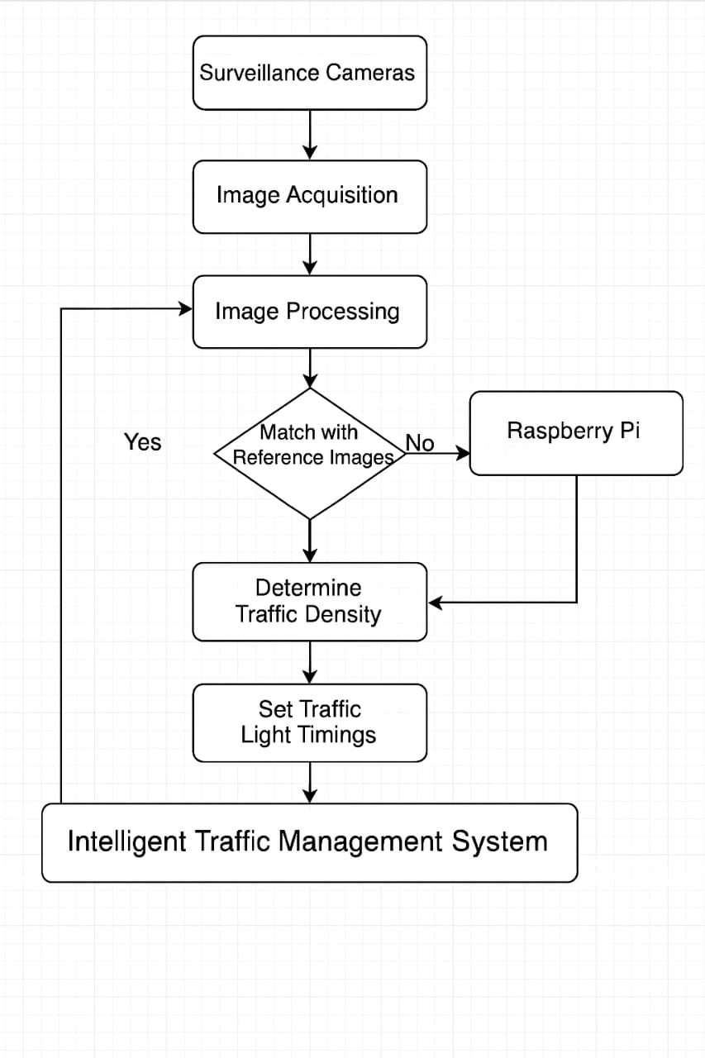

Fig 6.1 Architectural Design

**6.2 UML DIAGARMS**

**6.2.1 USE CASE DIAGARMS**

**1. Traffic Signal**

Control Traffic Lights: The system decides the timing of green/red lights based on traffic density**.**

**Upload Traffic Data: Sends data to the system for analytics or cloud storage.**

Capture Images: Some traffic lights may have cameras attached that capture live images of the road.

**2. Surveillance Camera**

Capture Images: Sends real-time visuals to the system, enabling image processing for traffic density estimation.

**3. Emergency Vehicle**

Detect Emergency Vehicles: The system can identify ambulances, fire trucks, etc., and give them priority at intersections.

**4. Police**

Extract Registration Numbers: Can use the system to identify vehicle number plates

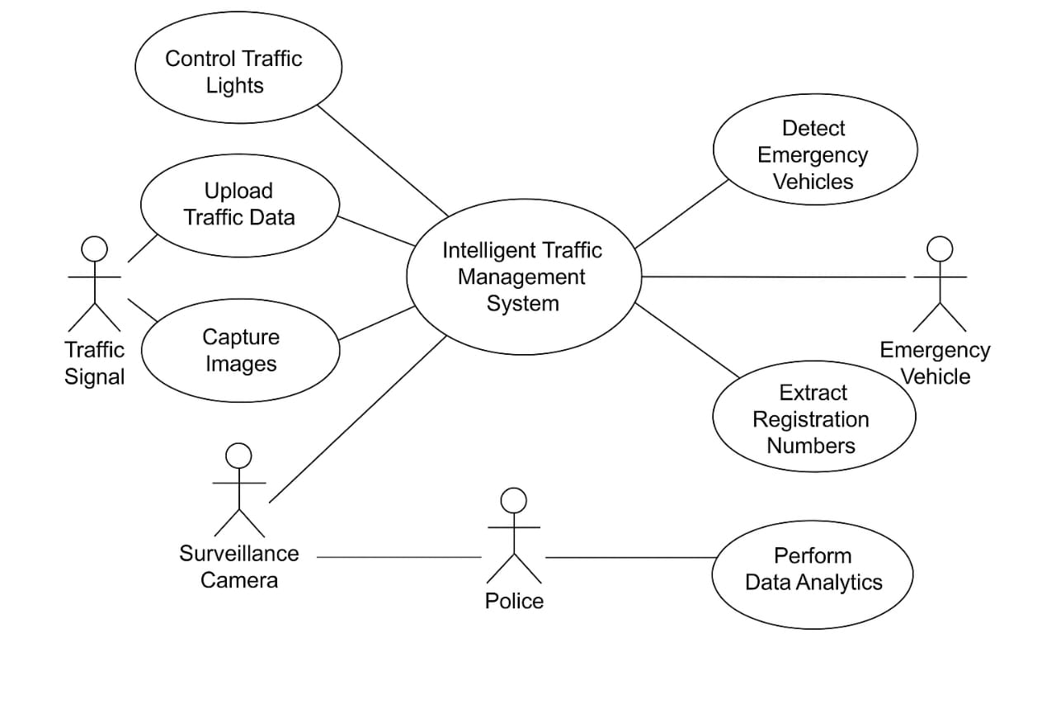

Fig 6.2.1 Use Case Diagram

**6.2.2 SEQUENCE DIAGRAM**

**Actors / Objects**

Student: Initiates resume and certificate upload for validation and verification.

System (Frontend): Provides the user interface for interactions between the student and the backend.

Validation Module: Processes and checks the resume content against academic requirements.

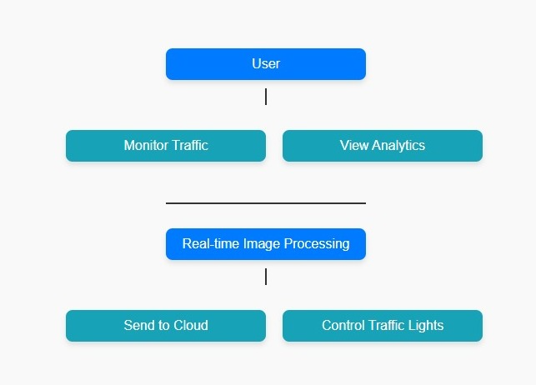

Fig 6.2.2 SEQUENCE DIAGRAM

**6.2.3 CLASS DIAGRAM**

**1. CameraModule**

* **Attributes:**
  + - cameraID
  + - resolution
* **Methods:**
  + + captureImage()

**2. ImageProcessor**

* **Attributes:**
  + - imageData
* **Methods:**
  + + convertToGray()
  + + applyEdgeDetection()

**3. DensityCalculator**

* **Attributes:**
  + - referenceImage
* **Methods:**
  + + compareImages()
  + + calculateDensity()

**4. SignalController**

* **Attributes:**
  + - greenTime[] (array or list)
* **Methods:**
  + + assignTime()
  + + controlLights()

**5. CloudUploader**

* **Attributes:**
  + - apiKey
* **Methods:**
  + + sendDataToCloud()

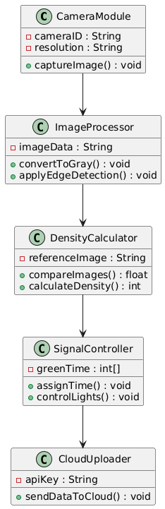

Fig 6.2.3 : CLASS DIAGRAM

**6.2.4 ACTIVITY DIAGRAM**

Step-by-Step Workflow:

1. Start

Beginning of the traffic monitoring cycle.

2. Capture Images from Cameras

Real-time images are captured from traffic cameras installed at different lanes (A, B, C, D).

3. Convert Images to Grayscale

Captured images are converted to grayscale to simplify further processing

4. Apply Edge Detection

Edge detection algorithms (like Canny) are applied to identify vehicles and traffic density.

5. Compare with Reference Image

Current frame is compared with a reference (empty road) image to detect vehicle presence.

6. Calculate Traffic Density for Each Lane

Based on the comparison, traffic density is calculated for each lane.

7. Assign Green Time Based on Density

The lane with higher density gets more green signal time; low traffic lanes get less.

8. Control Traffic Lights via GPIO

Raspberry Pi controls the LEDs/relays (traffic lights) using GPIO pins based on calculated timing.

9.Upload Data to Cloud (ThingSpeak)

All traffic data is uploaded to the ThingSpeak cloud for logging, visualization, and future analysis.

10. Repeat

The entire process is repeated at regular intervals to ensure dynamic traffic control.

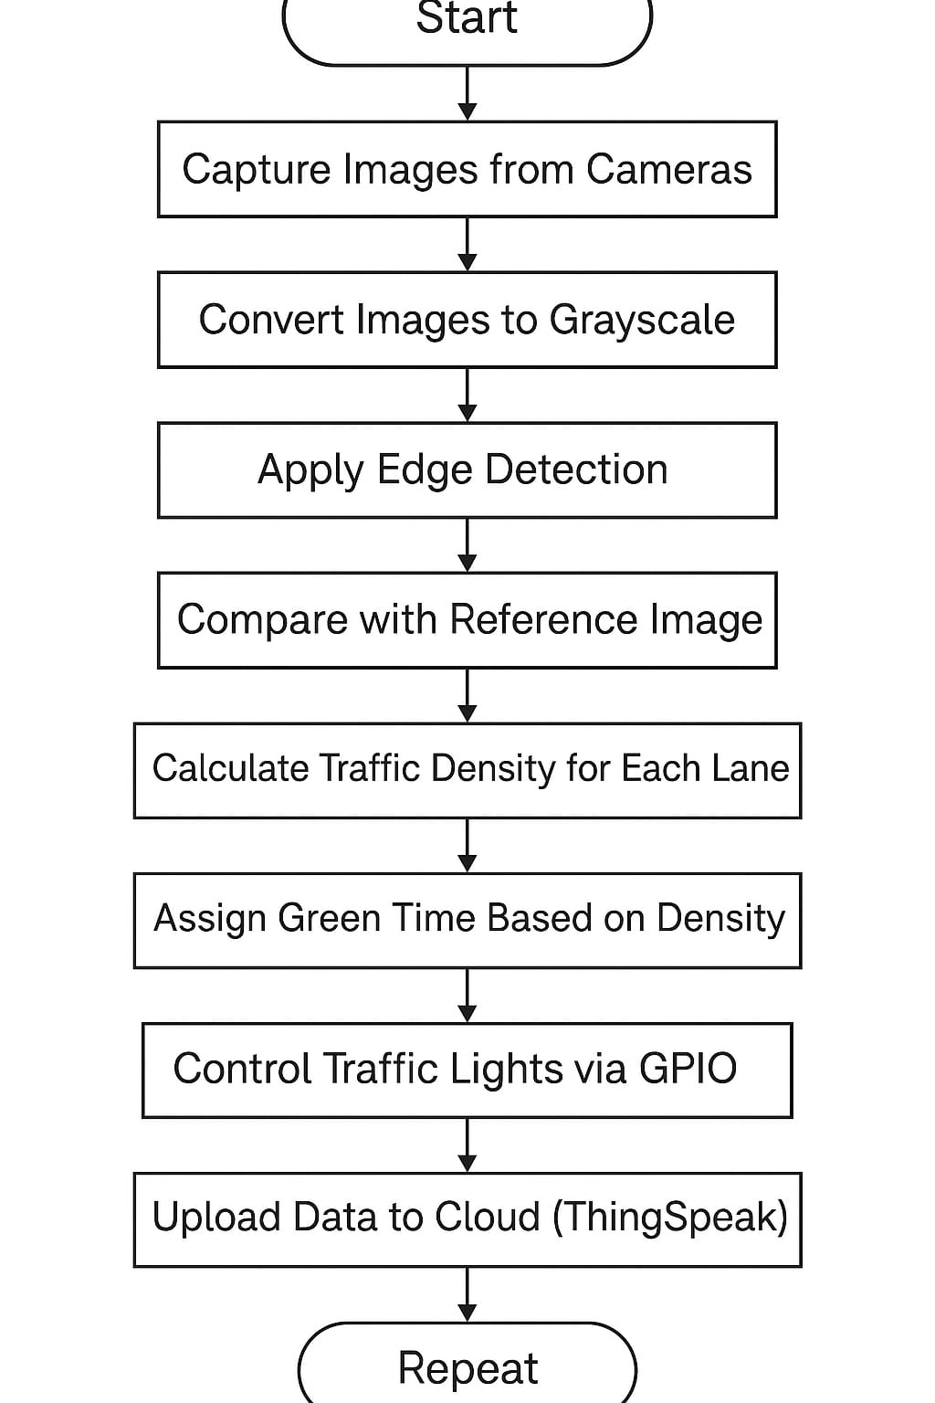

Fig 6.2.4 ACTIVITY DIAGRAM

**CHAPTER 7**

**CONCLUSION**

**7. CONCLUSION**

The Intelligent Traffic Management System designed in this project successfully addresses the critical challenges faced by traditional traffic signal control methods. By leveraging real-time image processing techniques, the system dynamically monitors traffic density at intersections and adjusts signal timings accordingly. This approach not only optimizes traffic flow and reduces congestion but also significantly decreases fuel wastage and environmental pollution caused by unnecessary idling at traffic signals.

The use of Raspberry Pi as the core controller, integrated with computer vision algorithms and cloud analytics (via ThingSpeak), ensures a scalable and cost-effective solution adaptable to various urban scenarios. The system’s ability to continuously upload traffic data to the cloud opens avenues for further data-driven traffic planning and management.

Moreover, the project lays a solid foundation for future enhancements such as emergency vehicle prioritization and vehicle identification through number plate recognition, which can further improve urban mobility and safety.

In conclusion, this project demonstrates how modern technologies like IoT, image processing, and cloud computing can be synergistically applied to create smarter, more efficient, and sustainable traffic management systems, contributing significantly towards solving urban traffic challenges.